MINI-BASKETBALL ENGLAND
AFFILIATION FORM FOR PRIMARY SCHOOLS & CLUBS

Membership of Mini-Basketball England an affiliate of England Basketball

NAME OF SCHOOL/CLUB:
SSP CLUSTER/ TOWN/CITY:

CONTACT PERSON:
POST CODE:
TELEPHONE:
E-MAIL:
BASKETBALL CLUB LINKS:
(Please list)
BASKETBALL QUALIFICATIONS & DBS | CURRENT DBS YES/NO
I would like to receive information on Take Six Mini-Basketball, the official primary basketball game. | YES/NO

To find possible ‘school to club links’ please ask your Sports Partnership or look at the club section on the Basketball England website; click on find a club and this should list all clubs both National and Local league clubs that your school could link to in your county.

Forms to be returned to:
Martin Spencer
Mini-Basketball England Education Officer,
4 Fairmead Rise, Northampton NN28PP
Tel: 01604 517732
Mobile: 07948381950
Email: martin.spencer12@ntlworld.com

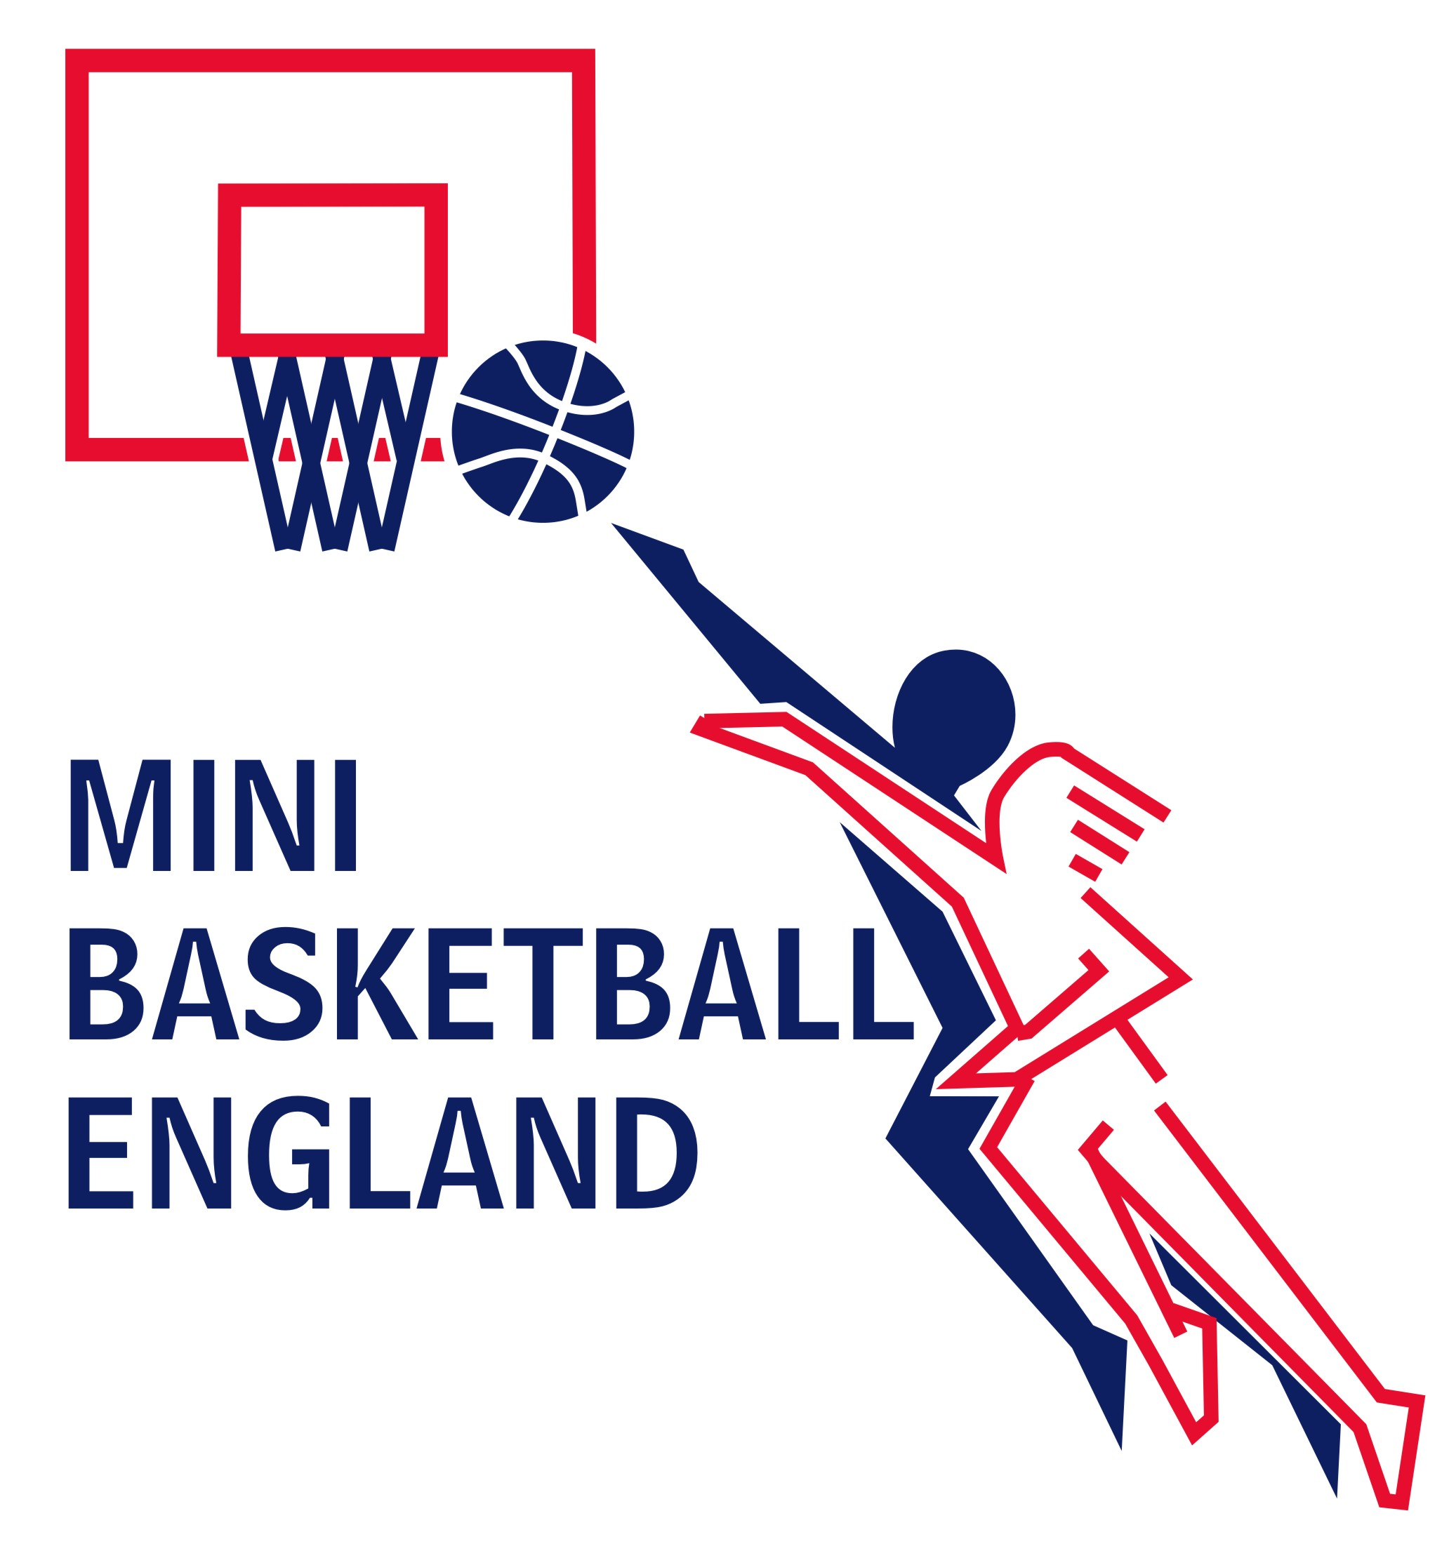

If you would like further information on Mini-Basketball please contact Martin Spencer as above.

