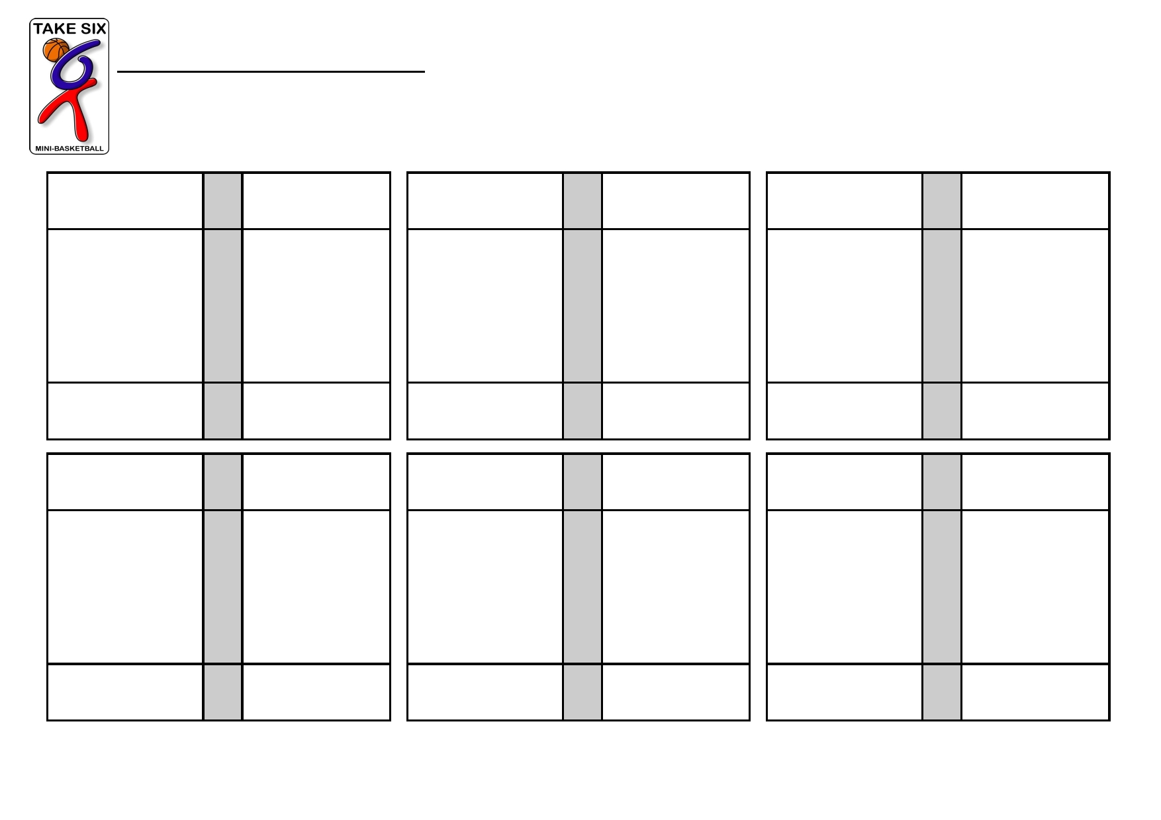
Take Six Mini-Basketball Score-sheet
Tally the score of each match.
2 points per basket

VS. VS. VS. s

VS. VS. VS.
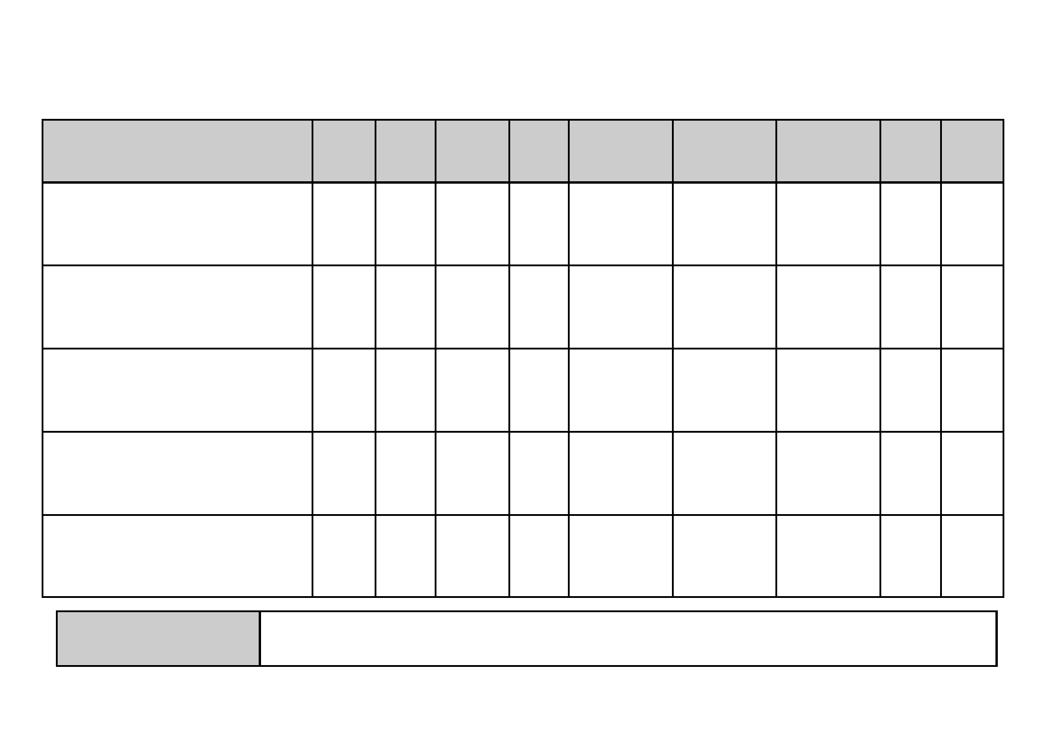
Win = 3 points Draw = 2 points Loss = 1 point

Goal

School
Played
Won
Drawn
Lost
For
Against
difference
Pts
Position

Winners

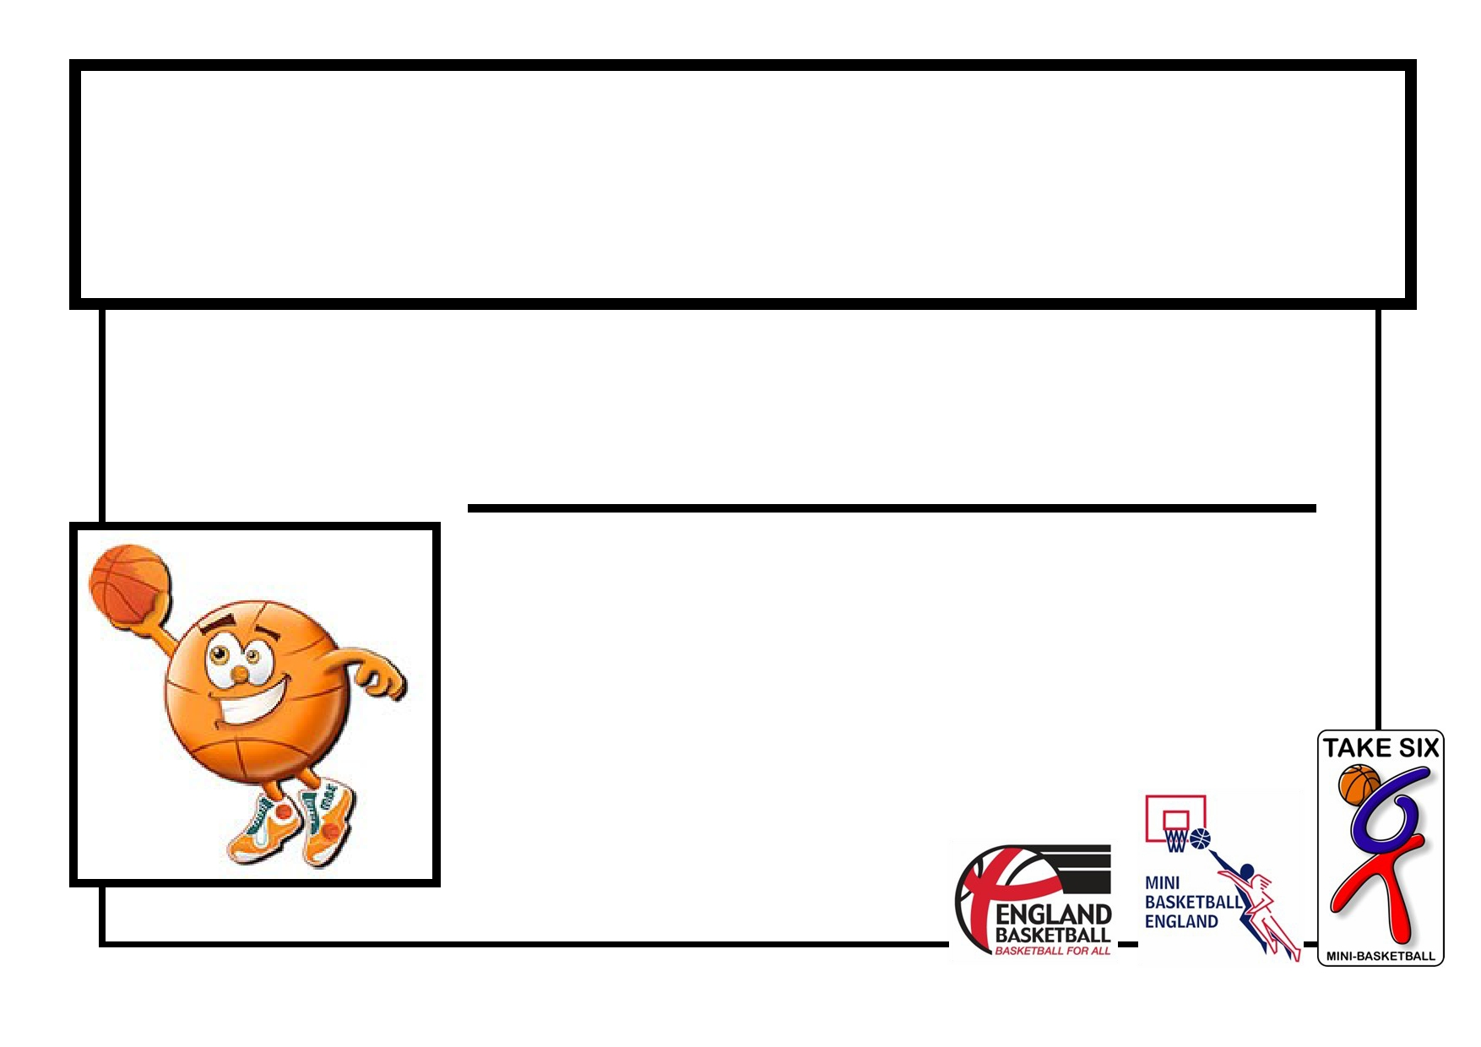
(insert event title)

This certificate is awarded to:

For your great participation and
sportsmanship

