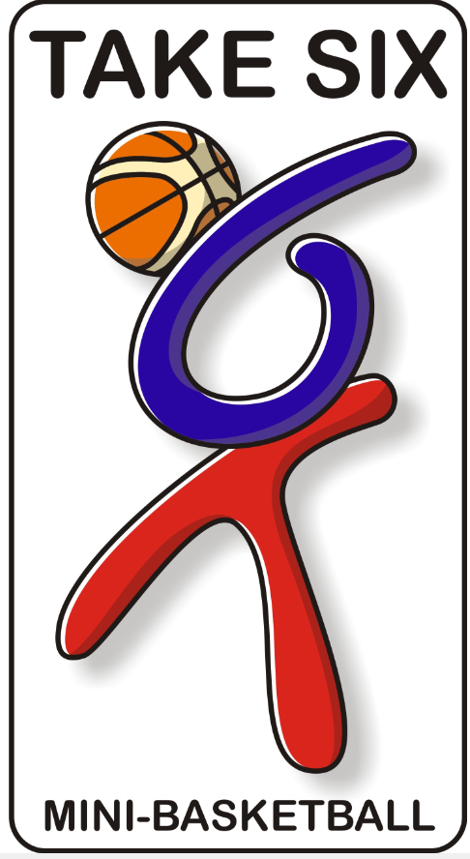
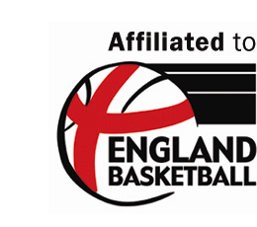


Places now available on the
National Mini-Basketball Licensed Training Course

The next Val Sabin Publications and Training Licensed Mini-Basketball Trainers Course is to be held in Northampton on

Thursday 22nd September 2011

Danes Camp Leisure Centre, Clannel Road, Hunsbury,
Northampton, NN4 0RX
9:00am – 3:00pm

A one-day Mini-Basketball England approved training course to prepare mini-basketball trainers to deliver courses for primary school teachers and young leaders.

Course Objectives:

- To develop knowledge and understanding of Mini-Basketball.
- To provide a guide to teaching and coaching.
- To introduce appropriate course material for teacher & leader workshops & training.
- To experience practical examples of appropriate Mini-Basketball activities

Course Content:

- Mini-Basketball, a game for children: Adapting the game of basketball to suit the requirements of children
- Planning & delivering workshops
- Familiarisation of the Mini-Basketball fundamentals: Agility, Balance & Coordination and Speed
- Developing game skills
- Introducing game rules including Take Six Mini-Basketball
- Competitive experiences
- National Curriculum: A programme of study for Mini-Basketball
- Risk assessment in Mini-Basketball

The course is essentially practical supported by theory as presented in the Licensed Trainer’s Manual. On the day licensed trainers will receive their own copy of Mini-Basketball, A Guide to Training & Coaching, a copy of Coaching Mini-Basketball by Martin Lee, Music CD’s for Mini-Basketball warm up activities and the Licensed Trainers Manual as part of the V.S P & T. training license.

Target Group: Partnership Development Managers, School Sports Coordinators, Teachers with some knowledge of basketball, Community Basketball Coaches working with schools.

Book now with:
Val Sabin Publications & Training
125 Harlestone Road, Northampton, NN5 6AA
Tel: 01604 580974 Fax: 01604 584643
www.valsabinpublications.com

